Toronto Child and Family Network

Terms of Reference
Approved June 13, 2019

Vision: All children and families in Toronto experience optimal well-being.

Mission: Mobilize the systems intersections that improve child and family well-being in Toronto.

Mandate: A table where system leaders respond, advance and champion system integration with an aim of improving quality, access and seamless service pathways for children (prenatal to age 12) and their families.

Values:
- All services will be inclusive, culturally appropriate and reduce inequity.
- The Network will engage in collaborative planning, striving for consensus.
- When mobilizing and planning system improvements, the Network will work with the community sectors and with families affected by the systems.

Members:
Members are staff who represent agencies, organizations and/or associations that work within the Toronto child and family sectors.

Membership at the steering committee will be leaders from the systems outlined below:
- Education
- Child Welfare
- Public Health
- Early years and child care
- Mental health
- Extra support needs and services
- Libraries
- Parks and recreation
- Health
- Ministry of Education
- Ministry of Children, Community and Social Services
- Major Funders
- Community organizations
- Post-secondary institutions

New members for the various committees and tables may be recommended for nomination by existing members, the advisories or the Network Development committee. Outside organizations that are interested may also reach out to the TCandFN@toronto.ca to express interest.

Nominated members are then vetted and approved by the relevant committee or appointed by the chairs/conveners. All nominated parties must first become members through an application process before being approved.

All new members must attend a 30 minute orientation to be on-boarded to the TCFN. An orientation package will be provided along with copies of the past 3-4 meeting minutes. In most cases, the backbone support will provide the orientation unless directed otherwise by the chairs. Best practice should have the backbone support go to the member organization to conduct the orientation in person.

Toronto Child and Family Network Goals: 2019-2024

TCFN has developed five outcomes for children, and five outcomes for families. Together they describe the well-being that we hope all children and families in Toronto experience. In partnership with the Indigenous community, outcomes for Indigenous children and families were also developed that reflect the specific needs and worldviews of Toronto's diverse Indigenous communities.

Improving these outcomes and the Growing Up in Toronto Challenges were the foundational basis through which the TCFN four goals were established in a year-long strategic planning process in 2018.

Every family can access information and navigate to services from a single point | Families can access comprehensive services with ease in their community | Every community has access to an integrated, comprehensive screening for early identification of needs. | Staff understand the needs of communities and how to work across systems to improve child and family well-being.

Toronto Child and Family Network Structure: 2019

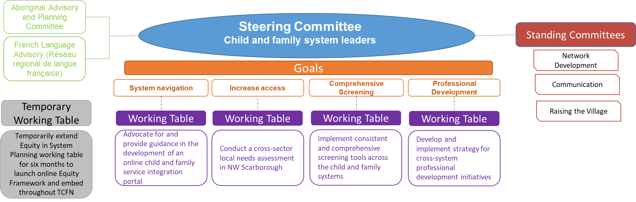

Terms of Reference review:
These Terms of Reference, including membership, will be reviewed every two years, or as needed, to ensure they support the work of the TCFN.

TCFN Committee Levels and Structure

Committee | Role and responsibility | Membership and meetings | Role of Chair/Conveners
Steering Committee | Provide oversight and direction to the TCFN to advance child and family outcomes  Create working tables, committees, and ad hoc groups as required; appoint members, direct, oversee, and monitor their work and that of the conveners, and recommend establishment of new advisory groups as needed  Commit to diversity of membership, across a wide range of characteristics  Seek input from TCFN advisories on major decisions, developed products, and strategic actions  Act as a conduit between the TCFN and respective member systems to mobilize for action  Actively encouraged to seek out community voice; ensure working tables intentionally include community voice to advise on needs, planning, implementation and system interactions at the community level  Provide resources needed to achieve strategic action (meeting space, staff time, resource development, key connections, etc.) | Senior representatives from child and family systems. See list above for current system representatives.  Meet five times per year, or as needed; able to appoint one designate to attend meetings to ensure system continuity  Members and/or designates are expected to attend all meetings. | Create agenda, chair meetings, and ensure decisions of steering committee are carried out and that working tables and conveners are on track to meeting goals  Oversee progress towards strategic goals and shared outcomes  Direct the work of the backbone support to align with strategic directions  Appoint new members to sit on steering committee and/or working tables
Working Tables  and  Standing committees | Implement strategic actions related to assigned deliverable  Accountable to the steering committee for deliverables and reporting back as directed, or at least once a year  If change in direction, conveners need to consult the steering committee | Representatives from member organizations who have a vested interest and/or are impacted by the strategic goals | Conveners are appointed by the working table and/or committees and approved by the group through consensus  Recruit, appoint appropriate and diverse members for working tables  Provide leadership in development of work plan and ensure decisions of the steering committee are carried out  Follow-up with missing members and keep member list up-to-date  Keep steering committee apprised of working table and identify linkages with other activities of the TCFN  Create the agenda, chair the meeting, and review the minutes  Sit at the steering committee and work closely with backbone support
Advisories | Develop and implement their own mandate and work plans to improve child and family well-being in Toronto for specific populations or issues  Provide ongoing strategic system advice in relation to the TCFN directions, goals, and deliverables; identity and bring issues and advice to the steering committee | Membership and meeting times, determined by Terms of Reference for each advisory | Role of chairs determined by Terms of Reference for each advisory  Chairs of the Advisory sit at the steering committee
Backbone support | Provide assistance, facilitate discussion, align activities, support development of deliverables, and improve functionality of all TCFN committees and working tables  Work closely to support chairs and conveners to achieve goals  Support agenda creation, minute taking, meeting scheduling, and member onboarding and engagement for all committees and working tables  Maintain a published list of TCFN members, Terms of Reference, strategic actions, meeting times, and minutes from the Steering Committee, Advisory, and Working Tables | The backbone support role is provided by Children's Services as the backbone organization of TCFN.  The backbone support work is overseen by the steering committee co-chairs
Members | Connect and learn about the work of the TCFN by receiving updates; members are eligible to serve on committees, advisories and tables | Any organization that directly serves children (prenatal to age 12) and/or their families in Toronto are eligible to become members
Decision making: Decisions are made by consensus where possible, and by majority vote as needed, for all above committees and working tables
